EPI Email Signature Guide

1. Open Outlook.
2. Begin crafting a new email.
3. Select the signature icon in the top menu. Select “signatures.”

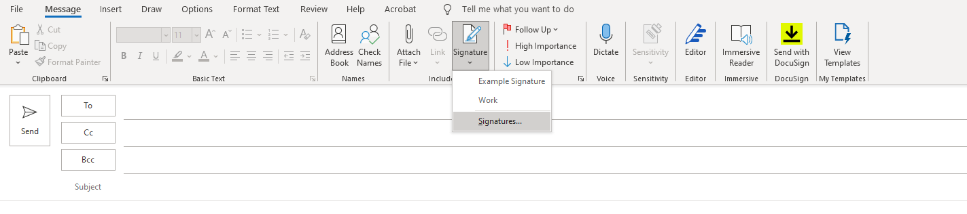

1. Select “new” to create your new EPI signature. A new analog box will appear. Give your new signature a name and select “OK.”

1. Copy and paste the following signature template into the design box (example of how it should look can be viewed in step 4).

|  |  |
| --- | --- |
|  | **Full Name**  Job Title  Emerging Pathogens Institute  University of Florida  [Email](mailto:a.sauvagere@ufl.edu)  Phone Number |

1. Change the fields to your information. Be sure not to change the font, font size or font color.
2. Once done select “save.”